

NOVAC TECHNOLOGY SOLUTIONS

User Manual

Document Version No.: 1.00

Revision History
Version No | Reason For Changes | Author | Approver
0.01 | Draft | Ravi Raj
1.00 | Reviewed & Approved the User Manual | Ravi Raj | NIJANTHAN PL

Table of Contents
1. Introduction 4
2. Non-Financial endorsement for CGL 4

Introduction

The document is prepared to understand and build an application for Comprehensive General Liability Insurance.

Non-Financial endorsement for CGL.

Endorsement refers to any amendment or change effected to a live insurance policy. It is imperative that the policy has to be active or live in status for the endorsement to be effected. The endorsement can be made effective from endorsement request date, the calculation to be effected either annually or pro-rata wise accordingly.

Path: CGL Endorsement -> CGL Non Financial
Screen Code: S0555

After enter the Policy number on clicking Go button, system will display the list of non-financial endorsements that are applicable for CGL policy.

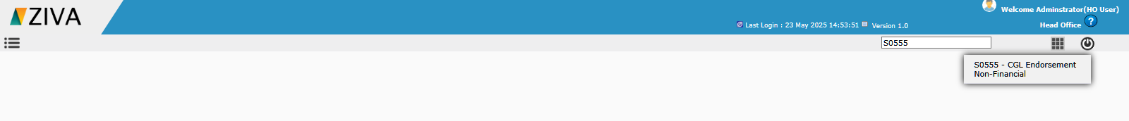

After selecting the respective checkbox against the endorsement click on Proceed button. After doing the changes in endorsement screen, click on Save button.

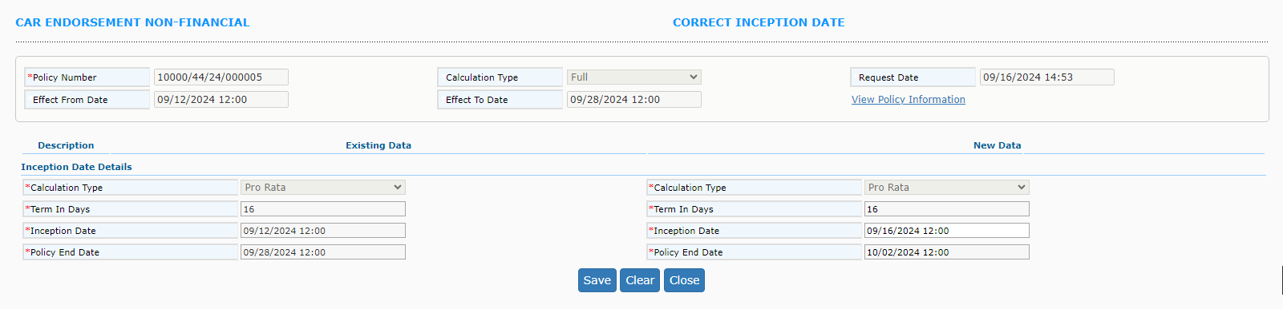
Endorsement is saved and endorsement no will be generated. Then user has to approve that record in endorsement approval screen.

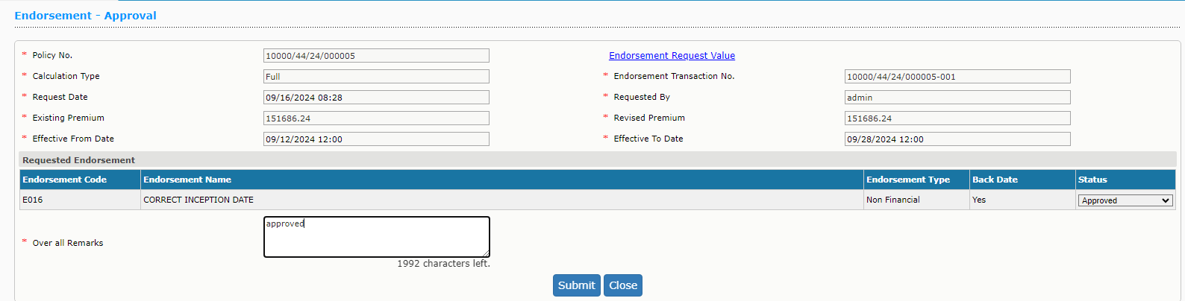

Then in confirmation screen, submit the record.

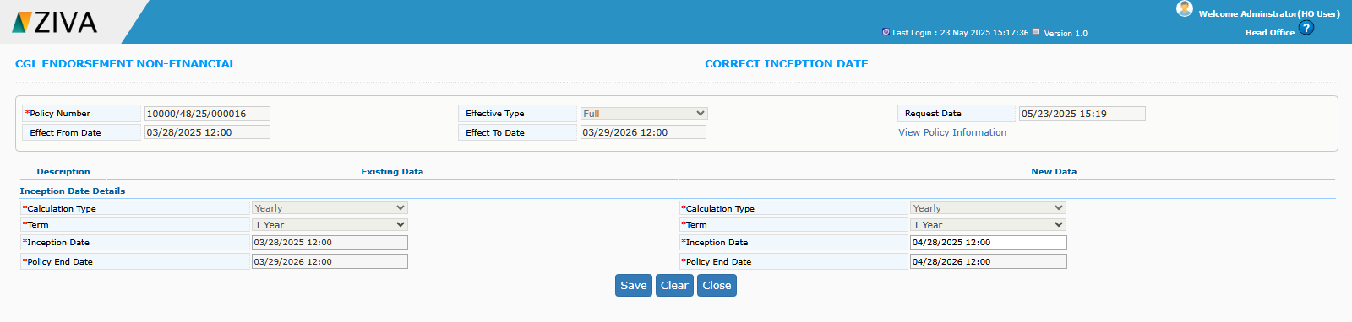

Once submit the record, download schedule button will be enabled. By clicking, the button user can able to download the endorsement schedule.

